UDP File Transfer Results

Task 1:

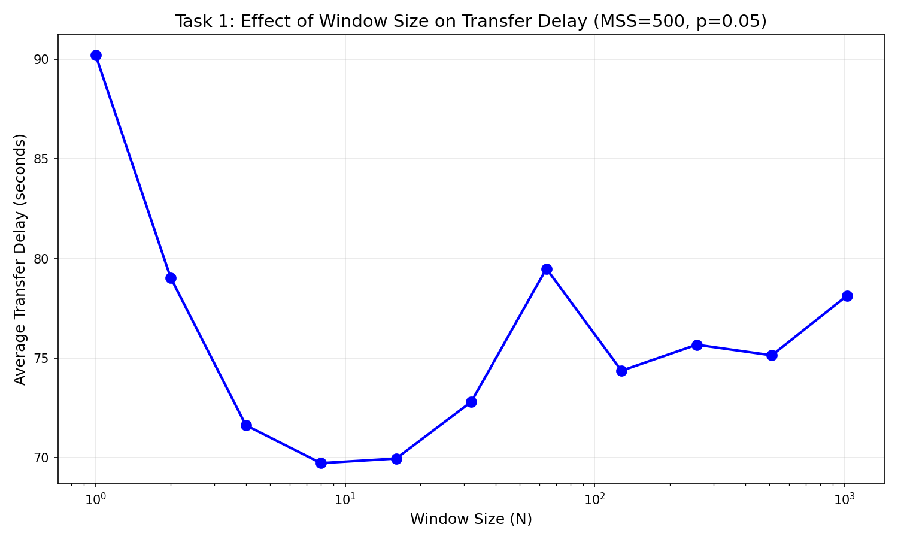

Interpretation: Increasing the window size reduces transfer delay at first, because the sender can keep more packets in flight and use the link more efficiently. The improvement is strongest going from very small windows to moderate ones, then the curve flattens and becomes a bit noisy, which suggests diminishing returns once the wind

Task 2:
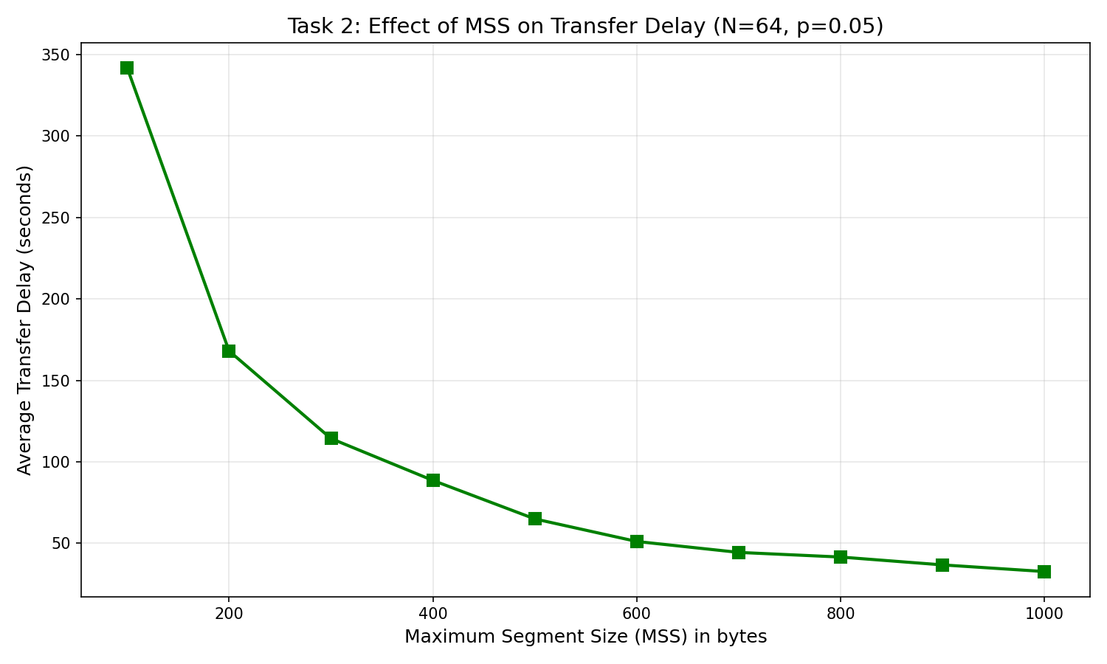

Interpretation:Larger MSS values consistently lower the transfer delay. This is the clearest trend of the three plots: sending more data per packet reduces protocol overhead and the number of packets needed, so the file finishes much faster as MSS grows.

Task 3:

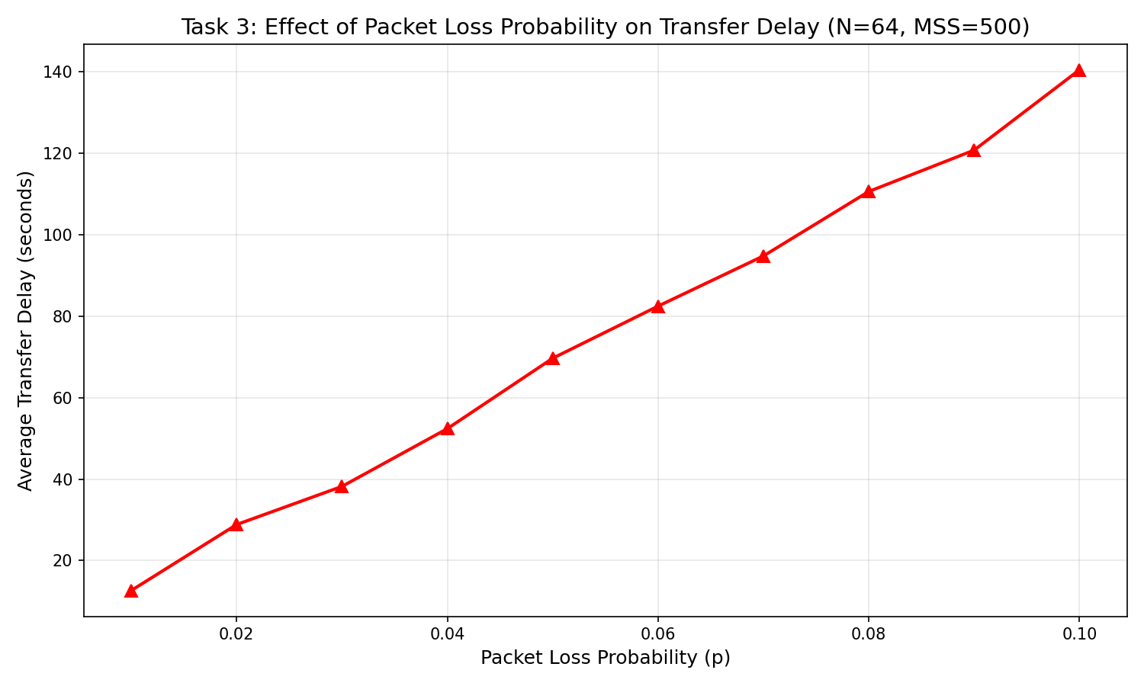

Interpretation:As packet loss probability increases, delay rises sharply. This matches Go-Back-N behavior: more loss means more timeouts, retransmissions, and wasted bandwidth, so the transfer becomes increasingly slow as the network gets less reliable.

